**Button Making Party Starter Kit**

*Button making parties are a great way to get people together and make cool stuff and cost next to no $$$ if you’re resourceful. Plus, wearing a button that has the word “ABORTION” on it is a GREAT way to start conversations about abortion in your everyday life—and that’s what SYA is all about! Here are some tips we have for how to make it all go down.*

**Step 1: Borrow / Rent / Buy a button maker.**

Borrowing stuff is always optimal, because it’s free. Maybe a friend of yours who is in a band already has a button maker! If not, you can buy one online, but they are not cheap (they range from $20-$200). But do some research--a lot of craft stores rent them out. You’ll have to buy the button making parts (plastic covers, backs etc.) separately, either online or at a craft store. You can also rent a paper cutter that is specially made just to cut out the paper for your buttons—just make sure you rent the right sized cutter to match your machine.

**Step 2: Organize your event!**

SYA206 in Seattle has organized a bunch of button parties so far—one was at a bike shop that let us bring in a bunch of tables that we borrowed, one was at a bar with DJs and dancing ([check out this awesome video on BUST!](http://bust.com/feminism/shout-your-abortion-goes-beyond-the-hashtag-video.html)) and some have happened at peoples apartments. How/whether you publicize your button party, the space you use, and the overall vibe is yours to decide.

**Step 3: Get supplies.**

You will need:

• Paper

• Scissors

• Art Supplies (you can also just use templates, but crafting is fun and special so don’t be lazy)

• Button parts (shells, pin backs). Make sure they’re the same size as your

button maker (they usually come in 1” and 2.25” but there are a bunch of less common sizes so just make sure your parts are all compatible with your machine)

• Computer (optional – to make new designs on the spot)

• Printer (optional – to print designs on the spot)

**Step 4: (optional) Print out some sheets**

Pre-print some button sheets if you want--either using the pre-designed ones in this kit or ones you design from the blank templates.

**Step 5: MAKE BUTTONS! MEET PEOPLE! TALK ABOUT ABORTION (IF YOU WANT)! HAVE A BUTTON PARTY! GIVE THE BUTTONS TO WHOEVER YOU WANT OR SELL THEM IF YOU WANT!**

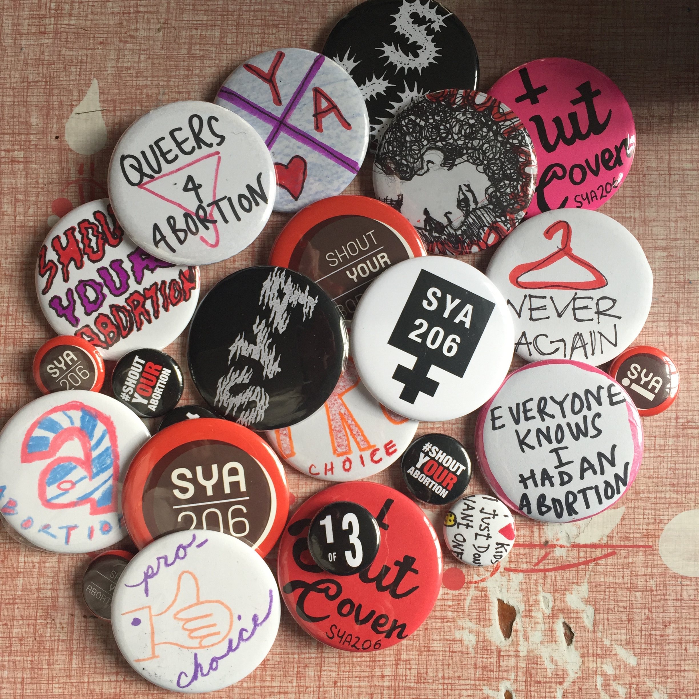

**Oh yeah--email us pics of your buttons/button partying (if you want), because it would make us so happy.** [**ShoutYourAbortion@gmail.com**](mailto:ShoutYourAbortion@gmail.com)